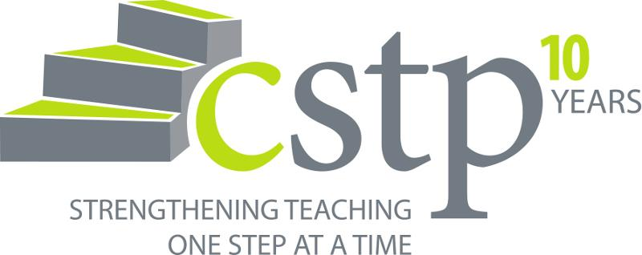

The Center for Strengthening the Teaching Profession (CSTP) is seeking session proposals from NBCTs who have attended previous CSTP NBCT Leadership Conferences. Our 2016 NBCT Leadership Conference is for new NBCTs wanting to learn skills to expand their leadership impact in schools and districts in Washington State.  We want YOU for our 'Green Shirt' team!

**Theme:** Impact, Influence, Inspire

**When:** May 14-15 at Sleeping Lady Resort in Leavenworth, WA

**Conference goals:**

● Develop strategies for expanding professional influence

● Promote high-quality professional development in the area of leadership

● Network with colleagues engaged in education reform around the state

We are seeking four 90 minute learning sessions. The Teacher Leadership Skills Framework will be the primary resource for the conference, and all sessions need to be explicitly connected to it.

If you would like to be a part of this amazing conference, please complete your session proposal by 5:00 PM Tuesday, March 1 via this [Survey Monkey link](https://www.surveymonkey.com/r/HBZK596). We are especially interested in proposals related to increasing teacher leadership capacity in challenging schools.

As you plan your session, please know that the most important part of the leadership conference is giving participants ample time to reflect on the learning and to connect it to their context. Consider how you might incorporate reflective opportunities in your session.

Presenters need to meet the following criteria:

● Your proposal meets one or more of the conference goals: Develop strategies for expanding professional influence, Promote high-quality professional development in the area of leadership, or Network with colleagues engaged in education reform around the state.

● Your proposal connects to the Teacher Leadership Skills Framework.

● Your proposal describes the content and activities of the session and provides opportunities to reflect and to connect the learning to individual contexts.

● Your proposal states how your session advances state, district, school, association or other teacher leadership.

● Your session is 90 minutes.

● You are an NBCT who has attended a previous CSTP NBCT Leadership Conference.

● Submit a session application online no later than 5:00 PM March 1st. Late or incomplete submissions will not be considered.

***Important:  Please answer all questions on a word document, then copy paste in the [Survey Monkey](https://www.surveymonkey.com/r/HBZK596).  Applicants must fill out proposal in one sitting... Survey Monkey will not allow you to return to a previous application.

Please send your questions to Cindy Rockholt at [cindyr@cstp-wa.org](mailto:cindyr@cstp-wa.org). You will be notified by March 18 if your proposal is accepted.

Thank you for your support of teacher leadership in Washington State.

Cindy Rockholt and Lindsey Stevens; NBCT Conference Co-Chairs

1. First Name and Last name as you would like it to appear on a name tag.

|  |  |
| --- | --- |
| Open-ended paragraph response |  |

1. School/District

|  |  |
| --- | --- |
| Open-ended paragraph response |  |

1. Grade, subject area, position title

|  |  |
| --- | --- |
| Open-ended paragraph response |  |

1. NBCT Certificate Area

|  |  |
| --- | --- |
| Open-ended paragraph response |  |

1. Email Contact (please check carefully as this is our main way to contact you).

|  |  |
| --- | --- |
| Open-ended paragraph response |  |

1. Best phone/cell contact number

|  |  |
| --- | --- |
| Open-ended paragraph response |  |

1. Do you work in a challenging school according to the 2015-2016 Challenging Schools list at OSPI? (Based on free and reduced lunch count; 70% Elementary, 60% Middle, 50% High School. To verify, [check the OSPI list](http://www.k12.wa.us/certification/nbpts/TeacherBonus.aspx)

|  |  |
| --- | --- |
| Yes |  |
| No |  |

1. Are you able to attend both days of the conference May 14 and May 15 and to present your session on May 15?

|  |  |
| --- | --- |
| Yes |  |
| No |  |

1. What is the title of your proposed session? (Something snappy for the program and the website… what title will compel people to consider attending your session?).

|  |  |
| --- | --- |
| Open-ended paragraph response |  |

1. Which conference goal(s) are supported by your session? Please check all that apply:

* Learn successful strategies to infuse NBCTs into local efforts.
* Promote high-quality professional development in schools across the state.
* Explore strategies for expanding influence from the classroom to schools, districts and beyond.

1. Write the goal(s) of session (after participating in this session, new NBCTs will be able to…): Example: NBCTS will be able to articulate three new strategies and write a plan to use the strategies for connecting with parents in Challenging Schools.

|  |  |
| --- | --- |
| Open-ended paragraph response |  |

1. Provide and overview/outline of the content and activities (with approximate times) of what your participants will experience in your session. (500 words or fewer, please). We’re seeking engaging, interactive, thought provoking sessions that embed reflection and explicit connections to the Teacher Leadership Framework.

|  |  |
| --- | --- |
| Open-ended paragraph response |  |

1. In what ways will your session use or connect to the theme of the conference, “Impact, Influence, Inspire”?

|  |  |
| --- | --- |
| Open-ended paragraph response |  |

1. Please write a three to five sentence “blurb” describing your session and why an NBCT may wish to attend. If your session is selected for the conference, this will appear in both the program and on the website. Make it zingy.

|  |  |
| --- | --- |
| Open-ended paragraph response |  |