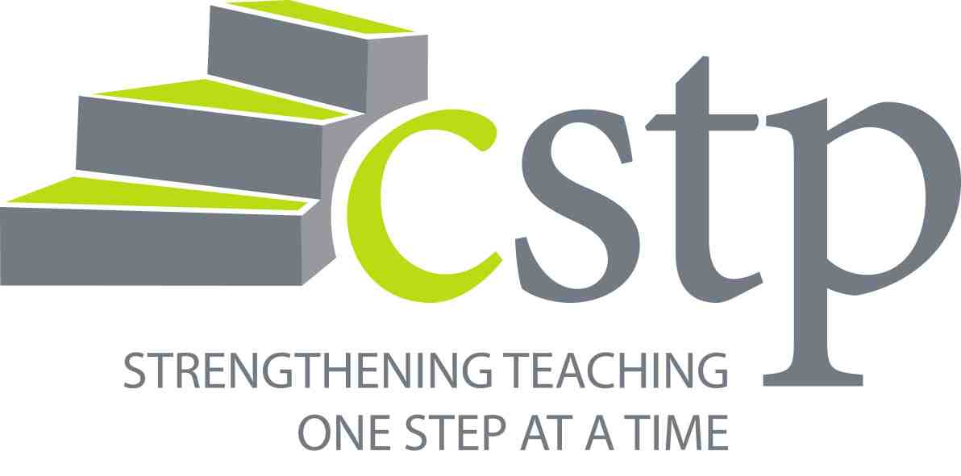

CLOCK HOUR APPLICATION FORM
(Revised to allow for STEM designation)

CLASS TITLE: _________________________________________________________________

DATE(S) & TIME(S): ___________________________________________________________

TIME(S) OF SCHEDULED LUNCH BREAKS: ______________________________________

CLASS LOCATION: _____________________________________________________________

TOTAL CLOCK HOURS REQUESTED: ________

BREAKDOWN: REGULAR HOURS ________ STEM HOURS ________

COURSE NUMBER ASSIGNED BY CSTP: CLOCK HOUR #_________________

CLASS SPONSOR: ______________________________________________________________

NAME, PHONE, & EMAIL OF INSTRUCTOR(S): ___________________________________

_______________________________________________________________________________

NAME, PHONE, & EMAIL OF APPLICANT (IF DIFFERENT THAN INSTRUCTOR):

_______________________________________________________________________________

MAJOR CLASS GOALS/OUTCOMES

STEM RELATED ACTIVITIES (see third page for WAC reference to STEM)

NON-STEM RELATED ACTIVITIES
ADDITIONAL EVALUATION QUESTIONS YOU WANT CSTP TO ASK PARTICIPANTS FOLLOWING END OF COURSE
1.
2.
3.

** ATTACH A VITA FOR EACH INSTRUCTOR ***

___________________________________________________ ________________________
SIGNATURE OF APPLICANT DATE

TO BE COMPLETED BY CSTP STAFF

DATE RECEIVED: | TOTAL CLOCK HOURS:
DATE GRANTED: | DATE NOTIFIED:
APPROVED BY:

DATE SIGN-IN SHEETS ARE SENT TO INSTRUCTOR:
DATE ELECTRONIC EVALUATION LINK IS SENT TO PARTICIPANTS:
Revised June 2016

The Center for Strengthening the Teaching Profession agrees to:

- Email registration forms to instructor a minimum of one week prior to start of course
- Post data from evaluations to website approximately 2 months after course ends
- Mail transcripts annually during the month of August

For more information, please contact the CSTP Clock Hour Specialist, Cindy Kleinfelter, at cindy@cstp-wa.org

REQUIREMENTS FOR CLOCK HOUR APPLICANTS

As an instructor or facilitator for professional development eligible for clock hours
through CSTP, I, ____________________________, understand the requirements and agree to abide by the following:
- Application must be received at least five working days prior to the first scheduled class or meeting date.
- Learning experience must be a minimum of three hours in length.
- Learning activities must demonstrate a clear link to specified goals and outcomes.
- Instructor assures that attendance is verified in writing by participants at each day of a class/workshop and notes any discrepancies on the sign-in sheets.
- Sign-in sheets must be submitted to CSTP within fifteen days of completion of event.
- Instructor can submit 1-3 content related questions to CSTP to be included on the electronic evaluation form distributed 3-5 weeks following event completion.
- Instructor will strongly encourage participants to complete the online evaluation.

_________________________________________________ ________________
Instructor Signature Date

New requirement per WAC 181-85-075 Continuing education requirement.
Continuing education requirements are as follows:
(5) Beginning September 1, 2014, continuing education or professional growth plans for teachers at the elementary and secondary levels in STEM-related subjects must include a specific focus on the integration of science, mathematics, technology, and/or engineering instruction as per RCW28A.410.2212. This renewal requirement applies to the following endorsement areas: Elementary education; early childhood education; middle level mathematics and science; secondary mathematics; secondary science; the designated sciences; and career and technical education. Certificates with a renewal date of June 30, 2019, and beyond must demonstrate completion of at least fifteen continuing education credit hours, or at least one goal from an annual professional growth plan with an emphasis on the integration of science, technology, engineering, and mathematics.
(6) Provided, as per RCW 28A.410.278(2) beginning September 1, 2016, in-service training, continuing education, or professional growth plans shall incorporate professional development on the revised teacher and principal evaluation systems under RCW 28A.405.100 as a requirement for renewal of continuing or professional level certificates. Certificates with a renewal date of June 30, 2019, and beyond for all teachers, principals, program administrators, and superintendents with continuing certificates must document completion of at least fifteen clock hours, or at least one goal from an annual professional growth plan, related to knowledge and competency of the teacher and principal evaluation criteria or system.

